
FMCDPHYSIOTHERAPY
Fiona McDevitt MISCP, MCPA, CST-T, MIACST
Chartered Physiotherapist, Craniosacral Therapist
Equine Assisted Learning Facilitator
LYMPH TAPING COURSE
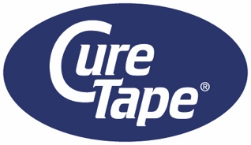
REGISTRATION FORM 
Name:
Address:
Telephone
Email:

Profession:
_______________________________________________________________
Please indicate if will bring Portable Table YES NO ________________________________________________________________
Total cost for course is €365. (includes all course material - workbooks, tape and scissors)
The course fee must be paid to confirm registration

NB: please forward evidence of payment with registration form:
PAYMENT METHODS
- Cheques – please cross and make payable to FMcD Physiotherapy Ltd
Postal Address: Fiona McDevitt, c/o FMcD Physiotherapy Ltd,
Suite 7a South Terrace Medical Center, Infirmary Rd, Cork
OR
- Electronic payment:
FMcD Physiotherapy Ltd.
Branch: AIB 26 Patrick’s St, Cork
BIC: AIB KIE 2D
IBAN: IE82AIBK93414350486032
NB: On Narrative please include “Your Name” and “Taping”

Please email to confirm payment to antoinetteoconnor877@gmail.com
- Downloadable form on www.fmcdphysiotherapy.com
I enclose payment of €365 YES

Signed: Date: ________________________________________________________________
Please return
- Completed form (Signed)
- Confirmation of payment (Scan/ Photo)
TO: antoinetteoconnor877@gmail.com
Tel: 087 222 6878 Fiona McDevitt

fiona@fmcdphysiotherapy.com
www.fmcdphysiotherapy.physio
7A South Terrace Medical Centre, Infirmary Road, Cork ~ +353 87 222 6878 MISCP Reg. 1558
Approved by VHI, Irish Life, Laya Healthcare

